**Synopsis**

**Bike Sharing Analysis In Tableau**

In this analysis I explored data visualizations centered around “Citibike”, which is a bike sharing business in New York City. The goal was to construct a presentation deck in Tableau that I could use to see if a similar company would be successful in Des Moines, Iowa.

**Results**

For my research I used data from the month of August 2019. I picked August because the weather in August is more favorable to travel via bike given the milder weather then other months of the year where it might be more comfortable to travel by car. The sample I was using had 2,344,224 recorded rides in August, of these 81% were rides that would categorized as "Subscription Based".

**Rides by Hour**

From my data it appeared that the busiest times of the day for riding were in the early morning and evening. The chart below illustrates this point quite clearly. [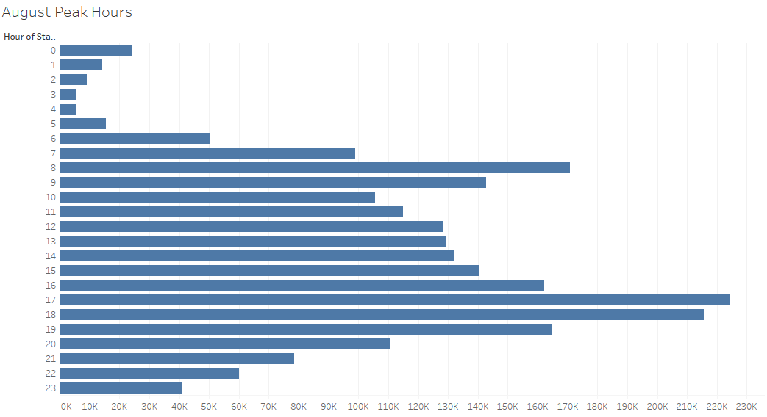](https://user-images.githubusercontent.com/104606589/184522288-6ef61f05-6694-4e37-b126-bc83fe874471.png)

**Demographic Breakdown**

The following charts show the breakdown of trips by Gender, time of day, and day of week. It seems that Female ridership is more concentrated on the weekends, and the Male and Unknown seem to have higher levels of riding Monday through Friday.

[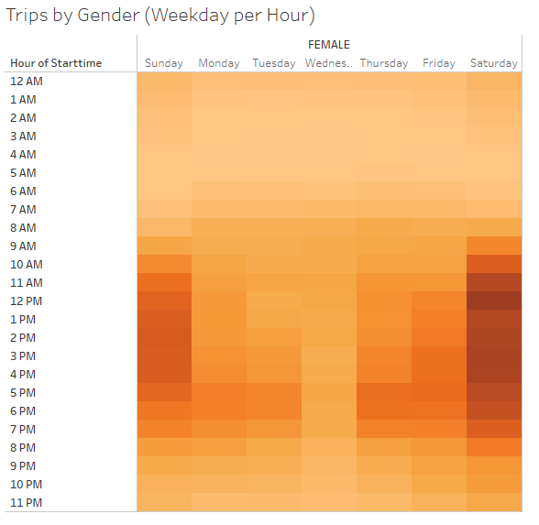](https://user-images.githubusercontent.com/104606589/184522457-e2ad0438-dc3d-4195-b486-1fc343eddeaa.png) [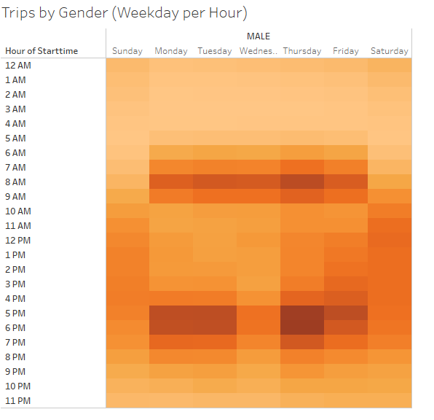](https://user-images.githubusercontent.com/104606589/184522461-be49f025-b0e0-4d57-b28f-8996c8ea0d7a.png) [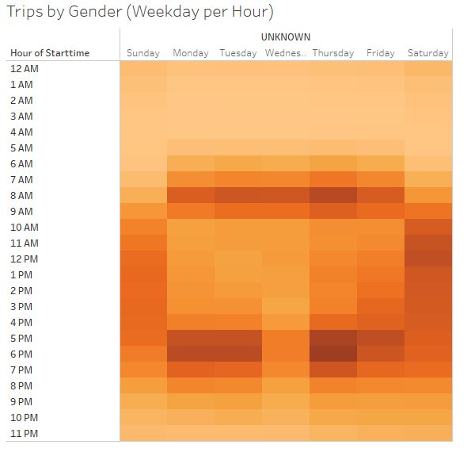](https://user-images.githubusercontent.com/104606589/184522463-c33c8d03-03a0-4488-bf97-1bd34d55d38d.png)

Digging into this a little more the chart below shows the geographic starting point of the rides for August. It appears that most of the rides start south of Central Park.  
[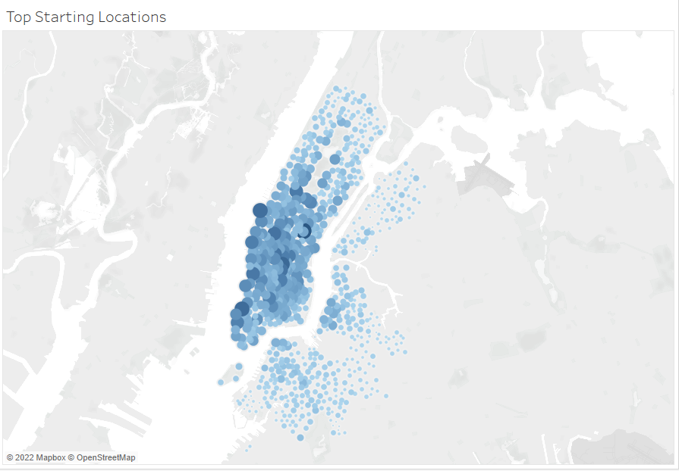](https://user-images.githubusercontent.com/104606589/184522497-03dcd4cf-bbad-4d66-bb77-bf32375b3517.png)

The next chart shows the breakdown for Walk up Customers and Subscribers by day and Gender. It appears that most of the ridership participation is among Male subscribers on any given day of the week.

[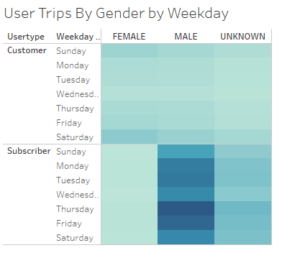](https://user-images.githubusercontent.com/104606589/184523078-7a85d40a-abf7-45b2-abb9-676fb64172b5.png)

**Trip Duration**

The next charts show the distribution of riders by trip duration. First as a total population then broken down by Gender. [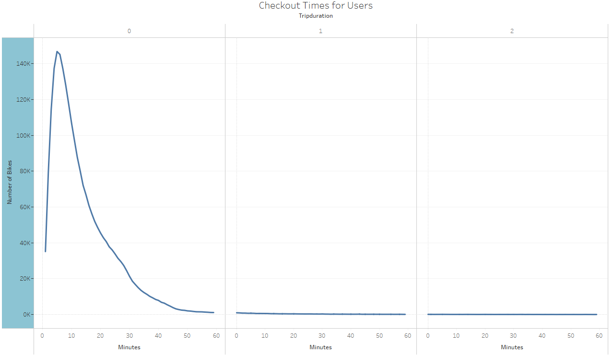](https://user-images.githubusercontent.com/104606589/184523133-b42426c7-b54d-4d0f-ad58-24e3079a439f.png)

[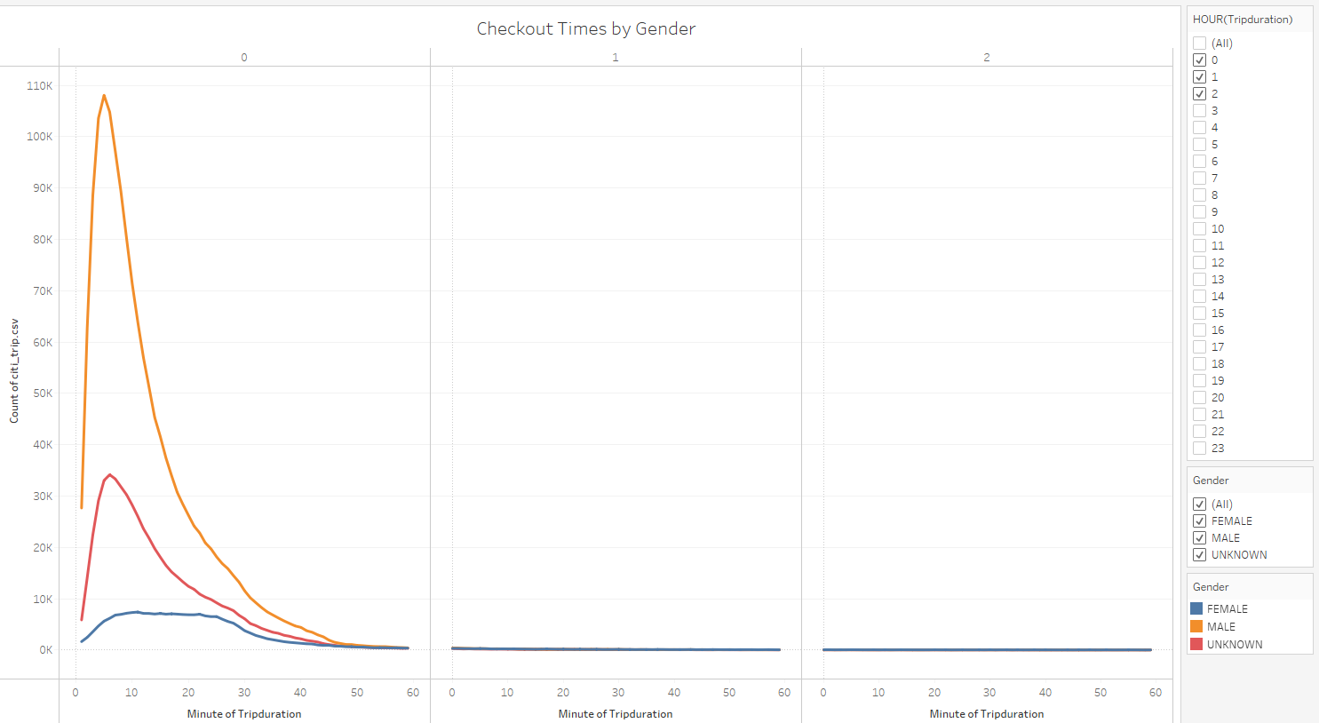](https://user-images.githubusercontent.com/104606589/184523142-95019cf7-e411-4245-91cb-9a8b0e91f9bd.png)

**Summary**

The Final tableau story can be found at:

[Bike Sharing Deck | Tableau Public](https://public.tableau.com/app/profile/chad.dewey/viz/BikeSharingDeck_16664713197040/NYCBikeSharing?publish=yes)

Doing the visualization gave me a good look at how the bike sharing program is working in New York. For New York it is safe to state that Male subscribers are contributing more than any other group that was compared.

* With more time I would add a visualization with trip distance by gender and day of the week.
* It would also be nice to see a visualization that showed economic and structural differences (income for subscribers, commute distance, and public transit options) between the two cities.
* A comparison visualization of Des Moines and New York by gender would be helpful in determining if it is a good idea to move forward with the program in Des Moines.
* Comparing population density would also be crucial to any success in Des Moines.